Indigenous Dignity: What OFRANEH and the Garifuna Struggle Teach Us
By Stephen (Esteban) Bartlett, photos by Steve Pavey.
Agricultural Missions, US Food Sovereignty Alliance (USFSA)
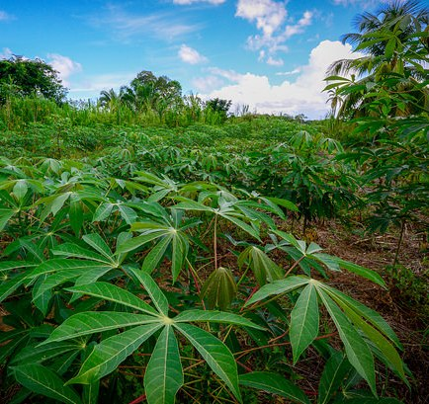
Subsistence gardens of cassava, plantains and coconuts in Dagadagati community, settled by Garifuna residents of Batalla community flooded out by tropical storm Gamma in 2005.
The first thing we need to understand about indigenous struggles for autonomy and cultural survival is that Land, Mother Earth, Pachamama is the beating heart at the core. Most modern urbanites may not feel this in its fullness, but rural people who rely directly upon land and watershed, river/lake/sea for their sustenance all know this is true. Access to land, fresh water and sea, and their natural biodiversity are the very stuff of life itself. The elders know it, the ancestors lived it, and those in struggle hold it in their hearts daily.
When Garifuna communities in Honduras run into problems of land tenancy, they call OFRANEH
What the Garifuna and their advocacy social movement OFRANEH (National Fraternal Black Organization of Honduras) demonstrate on a daily basis confirms this 100%. Whether the threats to cultural survival are out-and-out land grabs or loss of terra firme due to human-caused climate change, OFRANEH is at the cutting edge of struggles in defense of that land, those ancestral territories. OFRANEH unites and empowers Garifuna people and communities by promotion of their culture, through use of their unique and rich language including through their community radio stations, through the practises of traditional music and ancestral spirituality and ceremonial life passed down from time immemorial, and through efforts to promote ecological farming practices and sustainable small-scale fishing as a bulwark of autonomy.
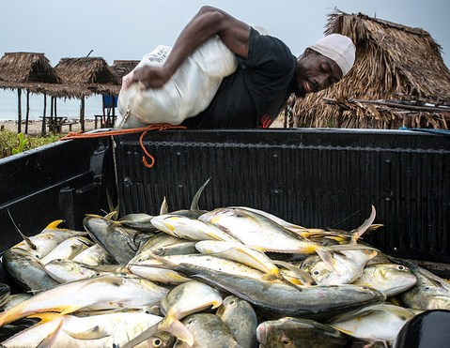
A member of the community of Barra Vieja, Tela Bay, Honduras helps off-load a fish- laden boat to a pickup. One hour later all these fish had been sold in nearby Garifuna and non- Garifuna communities, each large fish selling for $1.25 to $2.50 USD equivalent, a price affordable by common people. The Garifuna are feeding their diverse local communities.
Agricultural Missions’ fact-finding delegation documents threats and resilience.
On a recent visit to Garifuna territories October 17-25, 2014, members of the Agricultural Missions’ delegation I coordinated visited with and learned from members of communities resisting or enduring land grabs (Barra Vieja, Puerto Castillo, Trujillo, Nueva Armenia, Triunfo de la Cruz, Vallecito) and communities adapting to climate catastrophes and land loss from rising seas and flooding of inland lagoons ( Batalla, Dagadagati, Tocamacho). (see six blog posts documenting the visits in detail at: http://smallfarmerscoolplanet.wordpress.com ).
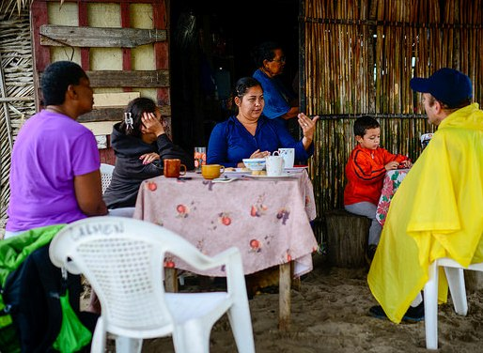
Community leaders in Barra Vieja, following an all-night vigil to protect the thatched homes there from the threat of arson by “elements” reportedly hired by the tourist corporation trying to take their lands. On September 29 and 30 dozens of police attempted, unsuccessfully, to evict the entire community that has lived here since 1918. See this video about the failed but traumatic eviction, click top right video at: http://ofraneh.wordpress.com/2014/10/28/exploracion-petrolera-en-honduras-areas-protegidas-y-cambio-climatico/
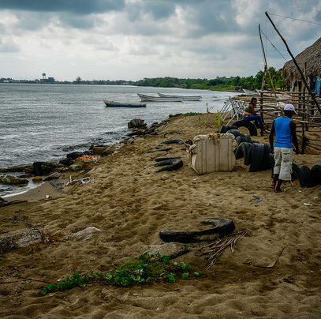
Puerto Castillo, an overcrowded town of mostly Garifuna displaced in 1983 by a ruling of “eminent domain” for the construction of what is today a major deep water port and Naval base (pictured in the background), where the Garifuna communities of Cristales and Rio Negro once thrived. Coastal fisheries have been degraded by pollution from the base and port, and the potable water system is in danger as well.
Political climate of Honduras worsened following the 2009 coup:
This is occurring in a political climate in Honduras that has been worsening since the illegal coup d’etat of June 28, 2009 that swept to power a clique of the top oligarchs of the nation in a series of maneuvers provoked by the forceful removal of then President Manuel Zelaya from the country dressed in his pajamas with a stopover en route to Costa Rica at the US air base in Palmerola. The post-coup maneuvers included an election overseen by the same military that staged the coup, an electoral process that was boycotted by a large majority of Hondurans and a subsequent election that was stolen from Xiomara Castro (the wife of the ex-President Zelaya) through a fraud that has been amply documented by international observers. For an in-depth interview in Spanish concerning the coup and its aftermath with OFRANEH international organizer Carla Garcia, go to: https://www.youtube.com/watch?v=4XKckq7MzYU
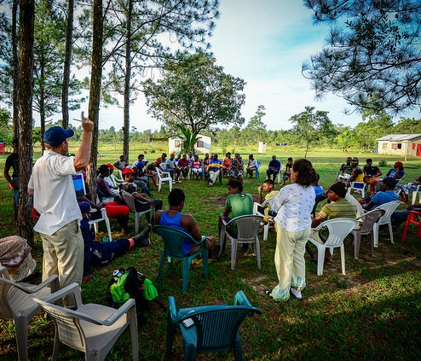
Parting dialog during Assembly with 60 Brigadistas and OFRANEH leaders in Vallecito.
Unfortunately, the U.S. government has played an enabling role for this series of post-coup regimes, providing political cover, military and police aid and looking the other way as the human rights violations have mounted. Hundreds of assassinations of opposition organizers and their family members have marked Honduras, bringing to mind the death squads of the 1980s that disappeared so many community members organizing in self defense in the region. Indeed, the level of impunity, the corruption of the police forces and judicial system, and the ramming through of land and mineral concessions to foreign investors as well as a series of Draconian laws to legalize this wholesale sell off of the country’s assets to the highest bidders have created a climate of generalized hostility to communities of the impoverished across the country, including in indigenous communities like the Garifuna, Lenca, Pech, Miskito, Maya Chorti, Tolupane communities and campesino movements across the country, particularly everywhere that African Palm plantations monopolize the lands.

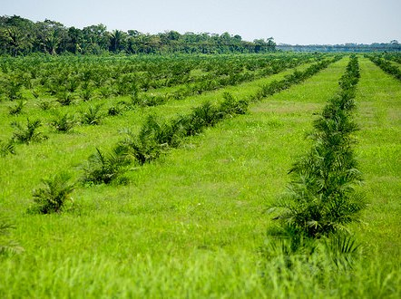
Honduras is, notoriously, a top producer worldwide of African Palm oil used to make biodiesel. The largest landholder of Honduras, oligarch and boss of 500 plus paramilitary guards (“security forces”), Miguel Facusse, also owns the Palm oil refinery Dinant corporation.
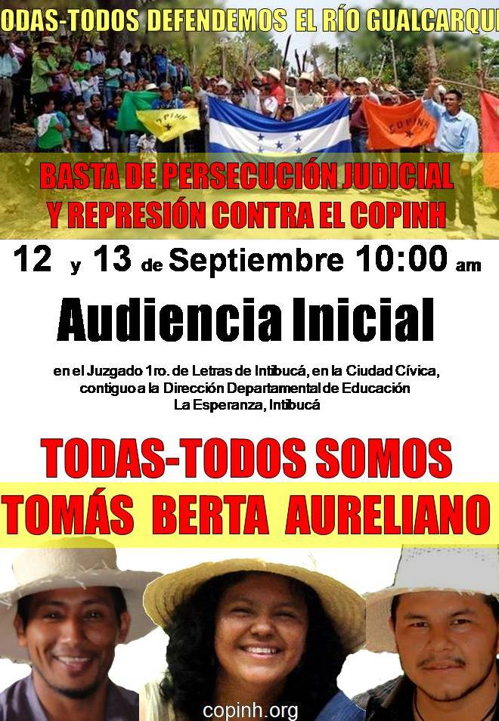
Flier for a solidarity action for three Lenca leaders persecuted due to their effective opposition a hydroelectric dam to be built on Lenca territory in Rio Blanco without the consent of the local communities. Convention 169 of the International Labor Organization (ILO) to which Honduras is a signator guarantees free, prior informed consent to any projects in indigenous territories, a convention the Honduran government has ignored. Flier produced by COPINH, a Lenca land-rights organization and strong indigenous partner of OFRANEH.
Vallecito as Sanctuary for Displaced Garifuna and as Agri-Cultural Training Center:
The longterm vision of Garifuna president Miriam Miranda centers around the full recovery of the 2,500 acres at Vallecito, and its transformation into a center for Garifuna renewal, the resettlement of Garifuna peoples displaced from other coastal communities, and the strengthening of traditional Garifuna agriculture and culture in general, with youth leadership development central to this vision.
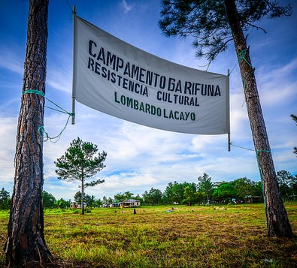
Vallecito: Lands Recovered from a Narco Trafficker in 2012 lie in the heart of Garifuna territories. Portions of the land have been invaded by campesinos, presumably with the support of Narco interests, due to the strategic characteristics- a runway, a hidden creek to the sea, the remote location-- of the land for clandestine drug running.
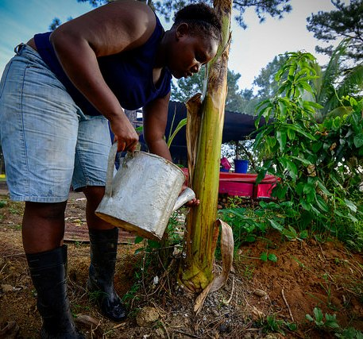
Youth Brigade member from an urban community learning agriculture in Vallecito as part of an agricultural work brigade of 60 youth.
Miriam points out that the government of Honduras has plans for a so-called “Charter City” (Ciudad Modelo is how the concept is expressed in Spanish), and one territory they have in mind is the north coast of Honduras stretching from the campesino community of Guadalupe all the way to east of Batalla in Garifuna and Miskito territory. If this were consolidated, dozens of Garifuna communities in the heart of the wider Garifuna territory would be in danger of displacement. Vallecito is located at the mid-point in this geographical extension, and therefore to OFRANEH holds a strategic importance. Garifuna dislocated from land grab fights that succeed for whatever reason, would in Vallecito have a place to resettle, particularly if the lands are developed agriculturally and aqua-culturally and as a center and “university” for Garifuna culture.
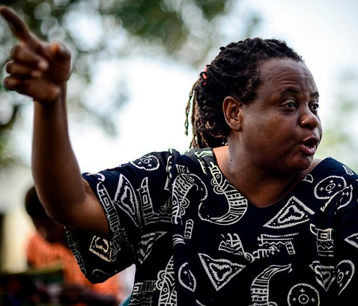
Miriam Miranda, president of OFRANEH, has a vision for the future of Garifuna territorial survival.
The skills and knowledge of Garifuna living in the more remote rural locations is considered vital to the transmission of this knowledge to new generations. During the youth brigade we participated in, a core of the youth present were from rural Sangrelaya, a kind of leavening of skilled farmers amidst a larger group of urban youth and young adults in need of those skills and knowledge.
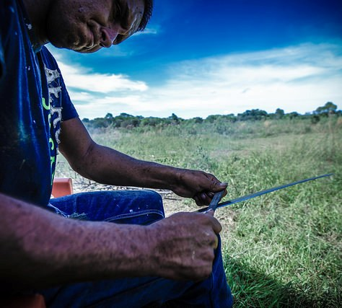
Rural Garifuna man sharpening his machete during “chapeo” (“mowing”) of lands slated for the construction of the Garifuna Cultural Center and Ceremonial site.
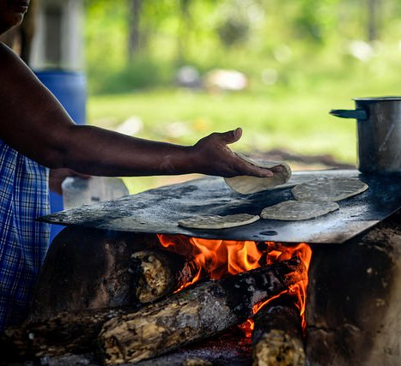
Teams of hard working cooks nourish the brigades visiting Vallecito, here making wheat flour tortillas.
Next steps in the implementation of this vision include consolidation of the recovery of all 2,500 acres in Vallecito, including the still-disputed lands adjacent to the beach, the construction of the Garifuna ceremonial/cultural building, and the continuing work of Garifuna participants in various work brigades that converge periodically at Vallecito. The land consolidation can be achieved by applying unbearable social movement pressure, both nationally and internationally, on the Agrarian Institute of Honduras (INA).
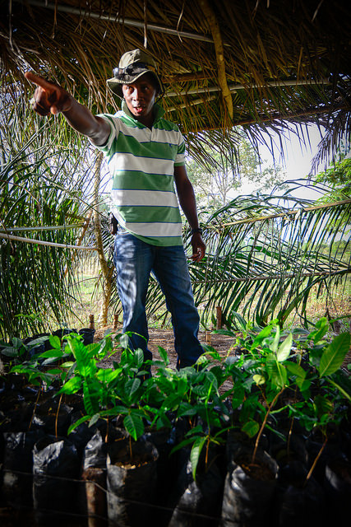
Garifuna agronomist Henry Morales explains to youth Brigadistas about reforesting the landscape with these mahogany seedlings.
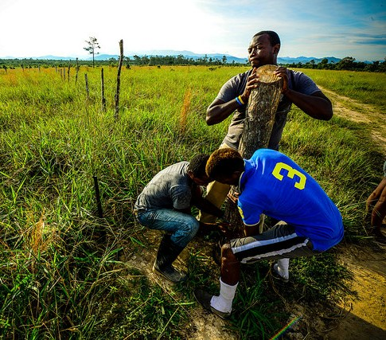
Garifuna Brigadistas and OFRANEH youth leader Nahun Lalin remove a fence post planted by the Narco invaders of the land prior to 2012 land recovery encampment that stood up to paramilitary threats and automatic rifle fire with drumming and ceremonies invoking the ancestors.
The traditional life styles of coastal Garifuna is a picture in community solidarity as well as a wealth of knowledge and skills adapted to the land, waterways and variegated ecosystems. All these need to be continually transmitted to new generations. The challenge of out-migration from rural to urban areas and even to the United States is one of the most serious threats to Garifuna cultural survival. This challenge too falls within the purview of the work of the leaders of OFRANEH who, during an Assembly of the youth brigadistas, held a dialog on the “fallen American dream” of an easy life in the U.S. and the political importance of autonomy on the land for true independence and cultural integrity. Miriam Miranda concluded her message about immigration to the 60 brigadistas in this way:
We were in New York recently. A large group of Garifuna women who went with their children had these electronic ankle bracelets on their ankles. You’ve seen them on facebook right? They say that they cannot leave the city. They are being constantly monitored. It is a nightmare for them. The American Dream has fallen. Because there is a crisis there. There in Detroit where they built cars and now they are so poor. It is incredible to see abandoned houses just like that everywhere. There are huge sky scrapers in Detroit that are just empty. And if you walk where the Garifuna live in NY you see all the garbage. You see people without jobs. People without work because there is a crisis.
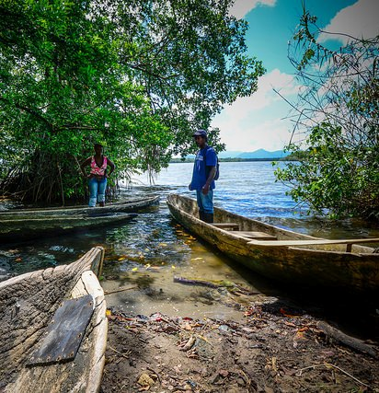
Traditional dugout canoes used in far east Batalla community to cross the freshwater lagoons to agricultural lands and pristine fishing grounds, and even for children to paddle to school in. The traditions live on, though trees big enough to carve into a dugout are more scarse than they used to be due to upland deforestation by non-Garifuna settlers.
The future of the Garifuna as envisioned remains a life worth living in a culturally and ecologically rich land and seascape. OFRANEH offers hope in the form of social movement and community organizing and advocacy, including international solidarity building. The International Liaison of OFRANEH located in New York City is one demonstration of the understanding that in a world of globalized oppression, the best, perhaps the only sure antidote, includes international solidarity. We of Agricultural Missions remain committed to following that path of accompaniment. To contact the author of this article, write to sbartlett@ag-missions.org and/or check out the website: www.agriculturalmissions.org and blog on the Honduras visits: http://smallfarmerscoolplanet.wordpress.com
Also check out the OFRANEH website at: www.ofraneh.org or their blog: https://ofraneh.wordpress.com/author/ofraneh/
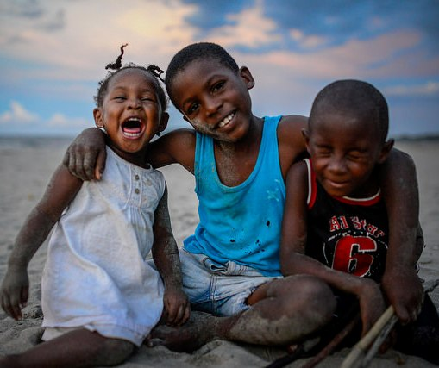
Garifuna children playing on beach in Triunfo de la Cruz, Tela Bay, Honduras.

