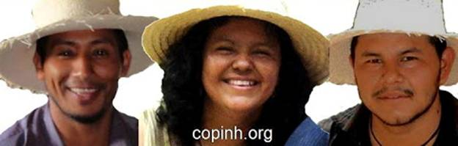**Agricultural Missions’ partner Berta Cáceres** (at center) is the highly respected and beloved leader of COPINH, the Council of Popular and Indigenous Organizations of Honduras. For decades Berta has guided and led the organization that has become one of the *strongest and most important social movement forces in her country.*  ***Berta was the 2015 recipient of the prestigious Goldman Environmental Award.***

**Organizing with a philosophy of radical inclusivity**, Berta has managed to build a social movement that honors and embraces women, youth, elders, feminists, LGBT persons, the disabled, peasants, indigenous and Afro-Indigenous peoples. With the historical memory of U.S. intervention in Honduras in the 1980s, when Honduras became a staging ground to arm the Contras who made violent incursions into next door Nicaragua against the Sandinista movement, COPINH has taken a strong anti-militarism stance. To build strength, they have organized thousands of Lenca people in 3 departments and have succeeded in securing recognition of the Lenca people and their territory as a collective good under the umbrella of Convention 169 of the International Labor Organization, to which Honduras is a signatory.

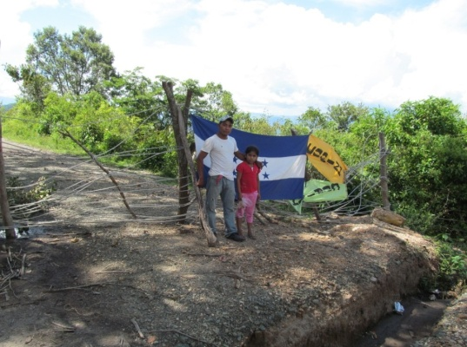 **In 2013 COPINH launched a dramatic effort to stop the plundering of their lands** and mineral resources by blockading the construction of a hydroelectric dam project in Rio Blanco, Honduras The blockade has held for months, despite repeated attempted evictions, judicial persecution of Berta and her companions, the assassination of a COPINH leader, and the militarization of Rio Blanco. Recently the World Bank has cut off loans for the project, the first signs that the COPINH effort will triumph in the end.

Since the 2009 coup d’etat against an elected president who was responding to the needs of the impoverished majority of Honduras, COPINH and Berta have become nationally prominent leaders in the movement for economic and social justice and for the re-founding of the country through a Constitutional Assembly. Her leadership has been crucial in halting the worst aggressions of the coup successor governments, in building unity and strength in the indigenous and campesino movements and in building a radically inclusive umbrella of people working toward the positive transformation of Honduras. **Agricultural Missions is proud to be an ally of COPINH and to struggle together with Berta Cáceres.**