COMMUNIQUE FROM VALLECITO, HONDURAS
FROM AGRICULTURAL MISSIONS, INC (AMI)
MAY DAY, 2013

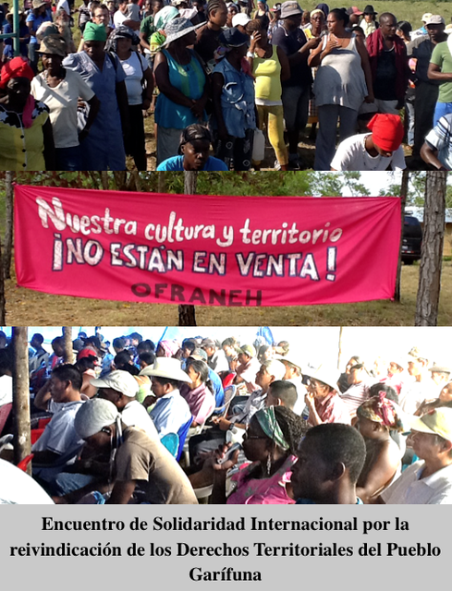
Captions: Our Garifuna territory is Not For Sale / OFRANEH
International Solidarity Gathering for the Claiming of theTerritorial Rights of the Garifuna People

From April 26 to 29, 2013 in Vallecito, Municipalidad de Limón, Dept. Colón, Honduras the International Solidarity Gathering for the Claiming of the Territorial Rights of the Garifuna People took place, as a collaboration between Agricultural Missions, Inc (AMI) and the Garifuna organization OFRANEH (the Fraternal Black Organization of Honduras) with the presence of representatives of the indigenous peoples of the Pech, Lenca, Miskito, Maya-Chorti, Tolupan and Garifuna Peoples, along with international representatives from Agricultural Missions, Inc (AMI), from a diverse Salvadoran delegation including social activists, students, and indigenous community leaders coordinated by Siglo XXIII, with volunteers from School of the Americas Watch and the Alliance for Global Justice, and from alternative media organizations. Delegates to this gathering hailed from the U.S.A., Canada, El Salvador, Guatemala, Germany, Spain, Haiti, Mexico, and France together with the Honduran First Peoples and select allies. Together we analyzed, discussed and took positions on themes of interest for our peoples and in particular for the Garifuna people. The Gathering studied the interrelated themes of Land, Culture, Climate and Sustainability.
We are grateful for the excellent hospitality of the OFRANEH hosts who prepared comfortable living conditions and excellent food for the more than 220 people gathered. We were impressed by the infrastructure improvements on what began as a humble encampment last September during the intensive campaign to re-survey the land, and which will serve to host the first permanent inhabitants and future visitors to the 2,500 acres of land in process of recuperation, 83% of which is still encircled by the fences erected by the land usurpers.
The Agricultural Missions´ delegation affirms our solidarity with the First Peoples of Honduras, and with the effort to recover and defend ancestral lands from usurpation and destructive forms of development. We understand the huge challenge of claiming ancestral land rights in a context of widespread impunity following violent crimes against the Honduran people following the 2009 coup d'etat. Large Honduran landlords as well as transnational and national corporations are taking control or more and more land, for the purpose of expanding already vast monocultures of African Palms to produce bio-diesel, for various mining and mega-construction projects and dams, and for forms of mega-tourism that callously displace people from their ancestral coastal lands. We understand the tremendous commitment and effort required to maintain and restore cultural integrity within the Garifuna and other Indigenous communities, at a time where youth and adults are increasingly enticed to migrate to urban areas where money flows more readily, many leaving Honduras altogether. At the same time, we rejoice at witnessing the powerful spiritual connection expressed by the traditional Garifuna ceremonies involving drums, maracas, singing voices, incense and a willingness to let the spirits of the ancestors flow through the bodies of the participants. This spiritual practice, we believe, is an essential and powerful, unifying and inspirational force for the maintenance of the traditional Garifuna culture and ways of life. We were also witness to the power of non-violent resistance. Miriam Miranda, the Coordinator of OFRANEH stated, “They had their guns, but we had our drums and our ancestors.”
We encourage the Garifuna people to pursue their strategy of resettlement upon these reclaimed lands, whether in Vallecito or in places like Trujillo and Tela and in all of the 34 Garifuna communities on the Honduran coast. We applaud the examples we witnessed in other Garifuna communities where agricultural production that is small-scale, low-input, diverse and aimed at feeding the community first before producing for sale and profit, is being developed and practiced. We challenge our sisters and brothers of OFRANEH and ourselves to follow through with solidarity actions and collaborations, including training and education and sharing of best practices in agro-ecology that will further a resurgence of traditional agricultural production, processing and distribution of grain, fruit and root crops, including the traditional elaboration of cassava bread, as well as, fishing and animal husbandry practices. We praise the vision of the Garifuna leaders to understand that secure land and fishery tenancy and access is an absolute prerequisite for the long-term sustainability of Garifuna culture itself.
We have proposed helping OFRANEH and the Miskito people send representatives to partner peasant organizations in Haiti to learn from their considerable experience with and knowledge of agro-ecological practices, and of their efforts to promote agrarian reform and to defend and pursue food sovereignty in all aspects, including prohibiting transgenic seeds in their communities. Like OFRANEH, the Haitian peasants are also fighting the development of agro-fuel monocultures that would supplant food production.
Echoing our Indigenous Sisters and Brothers we DENOUNCE the following:
-Violations of the International Convention 169 of the International Labor Organization and of the UN Declaration of Indigenous Peoples, denying previous, full and free consent before land is used or abused in any way, or people are displaced, sometimes violently;
-The increase in land grabs occurring across Honduras, followed by repression of family farmers attempting to re-occupy such lands for their survival, in practically all the departments of Honduras;
-The prevailing impunity, corruption and false witness experienced in the security and judicial systems of Honduras as well as in the oligarchy-controlled media;
-The unquestioning support of the U.S. government for the coup-successor government of Pepe Lobo and the National Congress, who ignore human rights violations including assassinations, violent repression and the jailing of those opposing the wealthy families' arrogant plunder across Honduras;
-The concessions of territories, rivers, forests, sub-soil minerals to transnational corporate interests for destructive profit-taking and in particular the hydro-electric dam by Agua Zarca corporation that the Lenca sisters and brothers of Rio Blanco are currently stopping through a rural road blockade;
-The pursuit of the ¨Charter Cities¨ (Ciudades Modelos) agenda and the remaking of Honduran law to accommodate such foreign enclaves within Honduras not subject to Honduran governance, security or taxation, that are slated to be located on indigenous lands without consultation and in violation of the international treaty enshrined in Convention 169;
-The displacement and theft of 14,000 hectares of land belonging to the Maya-Chorti people and their exclusion from ceremonial centers (Copan Ruinas) which now cater to tourists and to which Maya-Chorti people themselves are denied access;
-The massacre of four civilian Miskito people in Ahuas and the white-washing of that crime that was committed from a helicopter manned by US officers of the Drug Enforcement Agency (DEA);
-The implementation of false solutions to climate change such as the REDD+ (Reducing Emissions from Forest Degradation and Destruction) which serve to commodify the life in forested areas and subject it to capitalist markets and credit schemes that do nothing to stop the destruction and empower those with wealth and power to earn more profits from their harmful land practices;
-The continuing loss of cultural identity among indigenous peoples due to a State that is racist, classist, and discriminatory;
Therefore, we echo the calls of our Honduran partners and DEMAND that:
-There will be a cessation of land usurpation against indigenous peoples and family farmers of Honduras, and of collusions for that purpose with the Honduran government;
-There will be an annulment of laws such as the Special Economic Development Region (Charter City) law, the Mining law, the Hydrocarbon law, and Decreed Concessions of Rivers for Hydro-electric dams that impact the integrity of the Indigenous Peoples´ Territories;
-There will be government actions for mitigation and adaptation to climate change that go beyond the false solutions pushed by international financial institutions particularly for the coastal peoples Garífunas, Misquitas, Pech and Tawakas already severely impacted by storm surges and loss of coastal fringe lands;
-That the Honduran government respect Convention 169 of the International Labor Organization and that professional lawyers stop confusing the Honduran people by denying that international Conventions hold precedent over national laws, a principle made explicit in Article 18 of the Honduran Constitution;
-That protection orders be emitted to physically and psychologically protect community leaders of Indigenous organizations defending our lands and biodiversity, whose lives are under threat;
-We demand that once and for all the Honduran government cleanse and settle the title dispute of the lands that belong to the Garifuna people in Vallecito delivering to them access to all the fruits of this land;
-We stand in solidarity with our Lenca sisters and brothers impacted by open-pit mining on the lands slated for the Hydro-electric dam by Agua Zarca corporation;
-We demand justice for the families of those killed and wounded by DEA agents from the U.S. on the Patuca River in Miskita territory.
-We demand the release of José Isabel Morales, known as Chabelo from Guadalupe Carney, Aguan who is a political prisoner convicted and sentenced in a flawed judicial procedure.

Together with our Garifuna sisters and brothers we invoke the spirits of our ancestors, and prophets, from Abraham to Esther and Moses, from Isaiah to Martin Luther, from Martin Luther King Jr. to Cesar Chavez, from Jesus Christ to Sitting Bull and Malcolm X, and in respect of our very gracious hosts and partners, we amplify praise and respect for their historic heroes, namely Lambardo Lacayo who first envisioned a Garifuna place of sanctuary in Vallecito and who was assassinated for his struggle, to those who fought and resisted the yoke of those who would have enslaved them, among them the Garifuna and Indigenous leaders of Satuyé, Baráuda, Itaca and Lempira, and whose emancipatory sacrifices live on in the hearts of their descendants living today. As the Garifuna celebrate 216 years of presence in Honduras, they declare once again on April 30, 2013: Victory will be Ours!!

