AGRICULTURAL MISSIONS, INC.

INTERIM REPORT FOR THE WEST AFRICA INITIATIVE

JANUARY 1 – JUNE 30, 2025

YOUTH AGRICULTURE PROGRAM

SUBMITTED TO
GROWING HOPE GLOBALLY
AND
THE PRESBYTERIAN HUNGER PROGRAM

SUBMITTED BY
WINSTON CARROO
JULY 17, 2025

WEST AFRICA INITIATIVE INTERIM REPORT FOR 2025
BACKGROUND:
The food security situation in both Liberia and Sierra Leone continues to be dire especially for rural people. While weather conditions over the past year have been good and, while local food production has increased, inflation continues unabated, with annual food inflation rates of 52% in Sierra Leone and 30% in Liberia. Food production and distribution at the community level have provided some protection from these inflationary pressures for the basic food staples, with the storage facilities constructed over the past 3 years, contributing significantly to this outcome.
Over the past four years (2021, 2022, 2023 and 2024) the West Africa Initiative (WAI), with the support of Growing Hope Globally, implemented a highly successful food security program in 24 rural villages in Liberia and Sierra Leone, at the rate of 3 groups/communities per year in each country. During this period, the program focused on increasing the quantities of basic food crops through local production and facilitated the construction of food storage facilities, designed to reduce post-harvest loss and extend the period of availability of the crops produced. These food storage facilities proved to be critical in contributing to the improvement in the perennial “hunger season” problem by allowing stored food to be available during this season of scarcity. The youth of the participating communities were actively engaged in the leadership and implementation of this community food security effort as a way of simultaneously providing livelihood opportunities for themselves and improving food availability in their communities.
By the end of 2023, with the solution to the problem of seasonal food insecurity on the horizon in selected communities, the 2024 program on was focused improving the quality of the diet by promoting the production and distribution of animal sources of protein, mainly chickens (for eggs and meat) in Liberia and goats in Sierra Leone. Thus, the current (2025) focuses on the diversification of food sources through animal production, along with the necessary training and technical support.
PROGRAM GOALS: (Both countries)
- Improvement of food security and nutritional status in participating communities through increased availability of basic staple crops and animal protein in the diet.
- Development of income potential to youth engaged in animal husbandry.

Page 1
DETAILS OF THE 2025 PROGRAM
ACTIVITIES:
Overview:
Expansion of the program to new villages follows the “Village to Village” (V2V) methodology where existing groups assist new groups (usually in neighboring villages) in organizing themselves to meet the WAI criteria and ultimately joining the WAI program. This methodology, pioneered by the program in Sierra Leone, has been in use prior to support of Growing Hope Globally in 2021-2023. This methodology involves the voluntary support of new groups, by existing groups, in the form of mentorship, organizational development, training, material support such as tools, seeds and even cash loans for start-up costs.
In both countries, this project is being implemented within the West Africa Initiative Program (WAI) through Youth Agriculture Program (YAP). The groups selected in each country are members of WAI that have met requirements for democratic organizational structures, community credibility and engagement in some form of self-help and collective work. This is a continuation of the 2021-2023 program although some of the groups in the current year did not participate in the GHG/YAP program previously. The local implementing partner organizations are the West Africa Initiative of Liberia (WAIOL) and the Village to Village Federation (V2V) in Sierra Leone. These are independent country based Community Based Organizations (CBO) with their own Board of Directors.
While the overall goals of the program remain the same for each year (2024-2026), the objectives and corresponding activities are reviewed on an annual basis, to reflect current conditions, needs and priorities within each country. The details of the 2025 program are presented below, by country.
LIBERIA:
PARTNER ORGANIZATION: West Africa Initiative of Liberia (WAIOL)
Objectives:
- Food availability increased through the construction and use of storage facilities in three (3) villages where the WAIOL programs have been fully established.
- 15 youth from each selected village engaged in the construction and management of these facilities and in the production of food staples on 3 group farms.
- Nutritional status of 75 families in 3 villages improved through training and production and consumption of vegetables in home gardens.

Page 2
Activities:
For objectives 1 and 2
- Education and sensitization of groups, communities, and local leadership about the project.
- Mobilization of project resources.
- Conduct baseline surveys.
- Conduct (Farmer Field Schools) in various technical aspect of implementing the activities, including:
- Participatory project planning.
- Storage construction site selection (Village Based).
- Farming groups develop farm plans (Village Based).
- Farm production and store record keeping (Group facilitators and Group secretary).
- Commence specific farming activities based on the farming seasons (Village Based).
- On-going maintenance and technical support (Village Based).
- Conduct training in post-harvest handling and preparation for storage and completion of storage facilities (Village based, staff and facilitators).
- Data collection and Monitoring (Facilitators- Country coordinator).
- Project Evaluation and Reporting (WAIOL country coordinator-AMI program staff or consultant).

For Objective 3:
- Content and training materials developed in local languages.
- Training of Trainers (TOT) workshops conducted for facilitators.
- Project sensitization sessions held at appropriate community locations such as schools and community town hall, churches, etc.
- Community wide nutrition training conducted with a focus on using local foods to meet nutritional needs of various segments of the population.
- Hands on training sessions in vegetable gardening completed, concurrent with establishment of gardens and the distribution of seeds and tools.
- Ongoing technical support.
- Data collection (on-going), evaluation, and reporting.
- Introduce methods of preserving seeds for the next farming season.

Page 3

LIBERIA- WAI Program Participation Data for 2025

Group Name | County | Local community | Participants | Male | Female | Total Youth | Number of Beneficiaries
HCDA | Bassa | Gbor-Town | 15 | 6 | 9 | 15 | 83
Welekerma | Bong | Waterside | 15 | 8 | 7 | 15 | 96
United We Can | Nimba | Ganta Village | 15 | 6 | 9 | 15 | 110

LIBERIA: IMPLEMENTATION SCHEDULE FOR JANUARY 1, 2025-DECEMBER 31, 2025

Activities | Jan. | Feb. | Mar. | Apr. | May | Jun. | Jul. | Aug. | Sept. | Oct. | Nov. | Dec.
Awareness | xxx
B. Data collection |  | xxx
Land preparation |  |  | Xx | xx
Planting |  |  | Xxx | xxx | xxx
Crop Maintenance |  |  | Xx | xx | xx | xx | xx | xx | xx | xx | xx | Xx
Construction of storage |  | xx | Xx | xx | xx |  |  |  | xx | xx | xx
Train store managers |  |  | Xx | xx |  |  |  |  |  |  | xx
Nutrition |  |  |  |  | xx | xx |  |  |  | xx | xx
Home Garden |  |  |  |  | xx | xx
Leadership |  |  | Xx | xx | xx
Harvest and Preparation |  |  |  |  | xx | xx |  |  |  |  | Xx
Interim Evaluation |  |  |  |  |  | xx | xx
Final Evaluation/Reporting |  |  |  |  |  |  |  |  |  |  | Xx | Xx

All planned and scheduled activities for the period are being achieved within the time frame indicated above.

Page 4
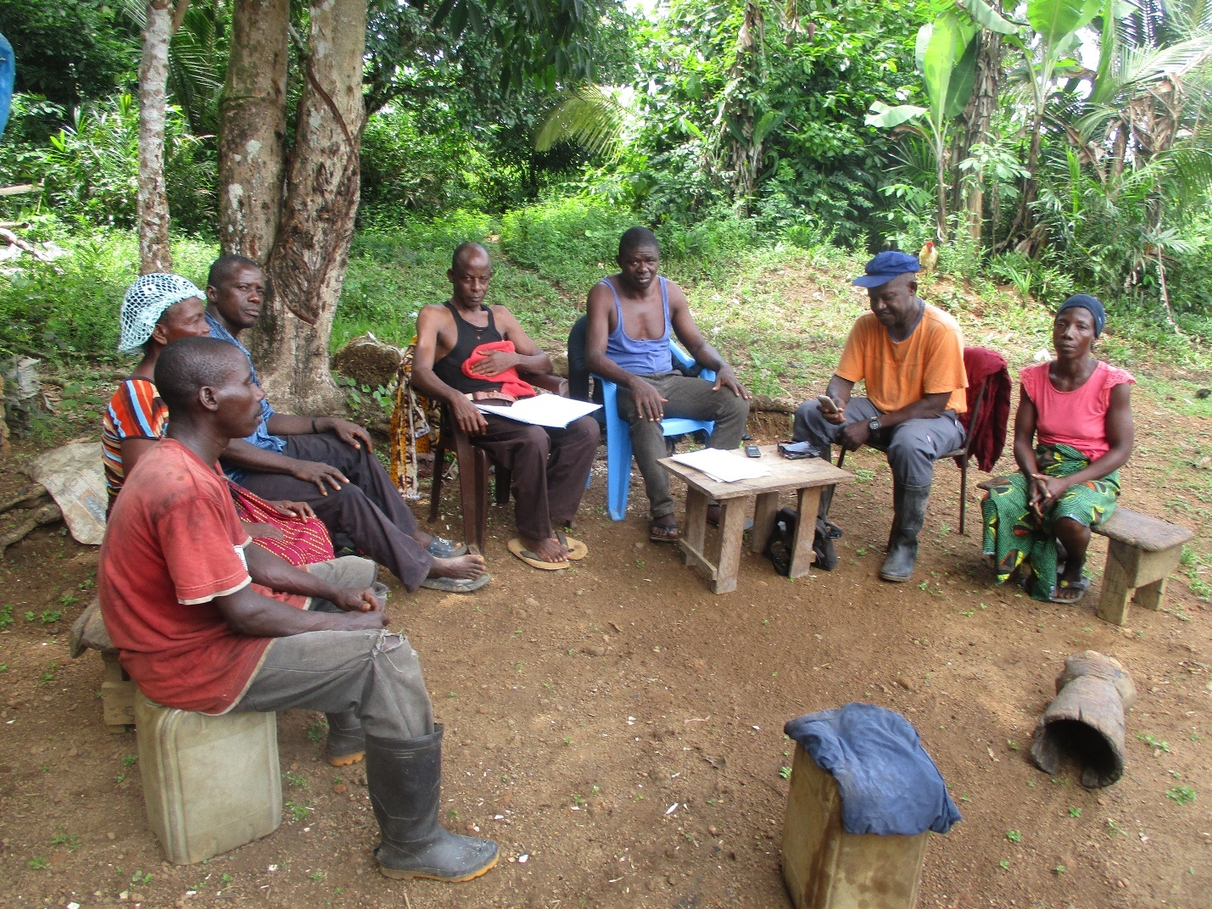

Amuyuu Group Nutrition Training: Grand Bassa County, Liberia

Page 5
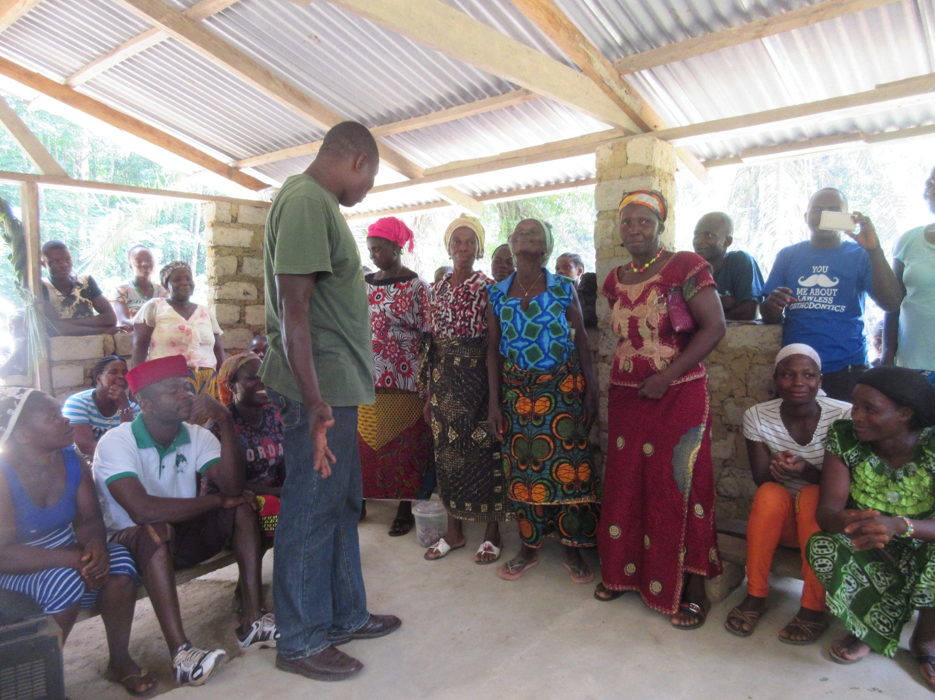

Village Nutrition Training: Old Force Group- Bong County, Liberia

Page 6

SIERRA LEONE.

PARTNER ORGANIZATION: Village to Village Federation (V2V)

Objectives:
- 10 young farmers from 10 different communities provided foundation breeding stock of 3 goats each, training in goat rearing and construction of goat housing.
- Net income of $900 is realized from the sale of goat offspring by each group.
- Improved nutrition in 45 families achieved through nutrition education and establishment of home gardens.
- 20% increase in the production, over the previous year, of staple crops by each group.
Activities:
For Objective 1:
- 45 youth from 3 groups trained in animal husbandry practices and disease prevention.
- Goat shelters/housing constructed by each group.
- 3 community-based animal health services established.
- Animals distributed to each group as agreed.
For Objective 2.
- Marketing training is completed for all participants.
- Market links established with potential buyers.
- Record keeping and accounting training completed.
For Objective 3.
- 2 nutrition education campaigns to promote high-protein diets completed.
- 5 Nutrition trainings sessions completed for 75 community residents, with emphasis on using locally grown foods to constitute balanced diets.
- 3 Farmer Field School home gardening workshops completed.
- Distribution of seeds and tools completed during workshop events.
- Ongoing monitoring process established.
Page 7
For Objective 4.
- Data collection workshops are completed for staff and facilitators.
- Data collection forms completed, and schedule established for data collection.
- Ongoing support provided to group members in crop production and post-harvest handling

- Sierra Leone - WAI Program Participation Data for 2025
Group Name | District | Local community | Participants | Male | Female | Total Youth | Number of Beneficiaries
Gbonkolol | Tonkololi | Gbonkolal | 15 | 10 | 5 | 22 | 120
Liloma | Kenema | Liloma-Yaw | 15 | 7 | 8 | 20 | 140
Rowonlon Farmers | Kambia | Rowonlon | 15 | 8 | 7 | 20 | 95

Page 8

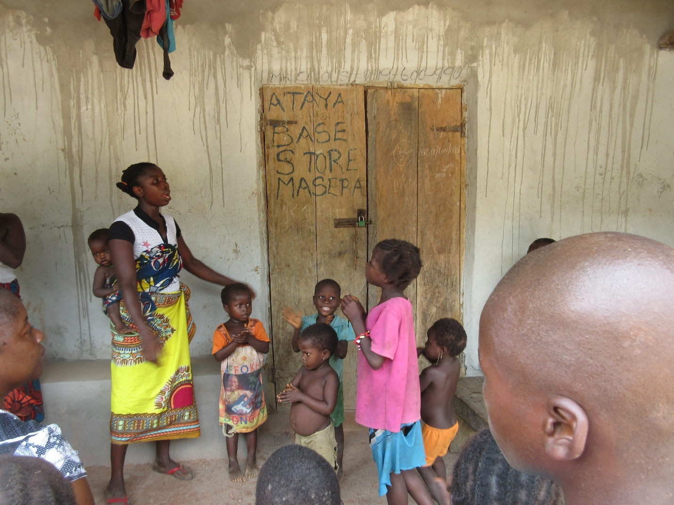

Storage doubles as school: Ataya Base Group, Masera, Tonkolili District, Sierra Leone

Page 9
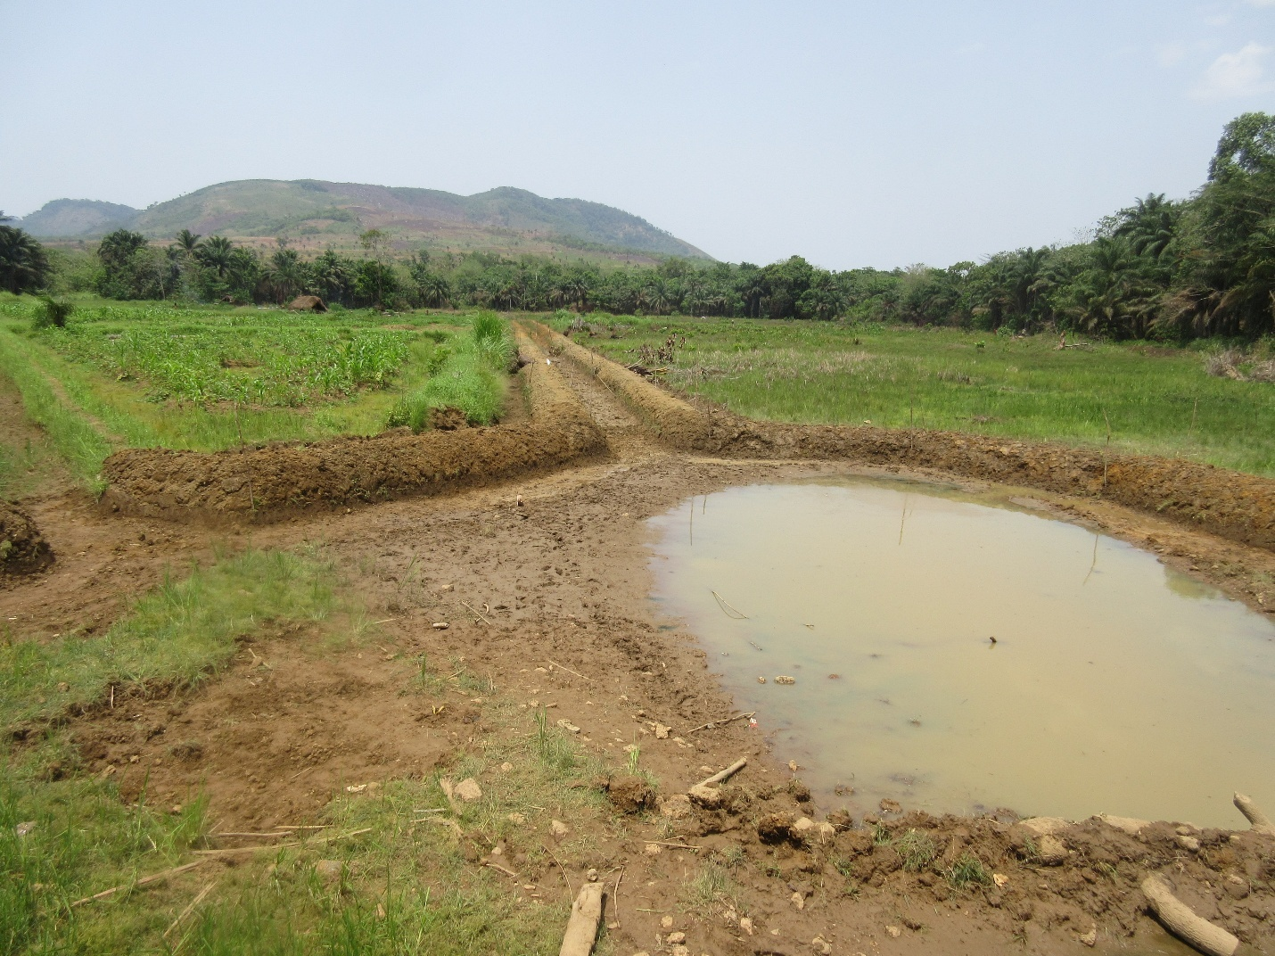

Youth Group Farm: Community Improvement Development Association (CIDA) Group, Tonkolili District, Sierra Leone

Page 10
SIERRA LEONE: IMPLEMENTATION SCHEDULE FOR JANUARY 1, 2025-DECEMBER 31, 2025

Activities | Jan. | Feb. | Mar. | Apr. | May | Jun. | Jul. | Aug. | Sept. | Oct. | Nov. | Dec.
Group sensitization | xx | xx
Tech Training (T) |  | xxx | Xxx
Goat House Cons (T) |  |  | Xx | xx
Goat Distribut (T) |  |  | Xx | xxx
Marketing (T) |  |  |  |  |  | xx | xx
Business and records (T) |  |  |  |  |  | xx
Monitoring/Tech Support |  |  |  |  |  |  | xx | xx | xx | xx | xx | Xx
Nutrition (T) |  |  |  |  | xx | xx |  |  |  | xx | xx
Home Garden (T) |  |  |  |  |  |  |  |  | xx | xx | xx | Xx
Leadership (T) |  |  | Xx | xx | xx | xx | xx | xx | xx | xx | xx | Xx
Harvest and Preparation (T) |  |  |  |  | xx | xx |  |  |  |  | xx | Xx
Interim Evaluation |  |  |  |  |  | xx | xx
Final Evaluation/Reporting |  |  |  |  |  |  |  |  |  |  | xx | Xx

All scheduled activities from January to June were completed on time, and similar results are expected by year-end.

Page 11

